|  |
| --- |
| Circle Language Spec: System Objects |

## Parameters For Objects

**[Preliminary documentation]**

### Concept

This is a preliminary description of the concept. The details are still to be worked out. It could be that in practice, when the new computer language is up and running, the details that have to be solved, will come to light straight away.

In other programming languages there are *getters* and *setters*, which are also called *properties*. Those are replaced by the fact, that any related object has a set of system commands, such as Object Get and Object Set, that can be extended with extra code around the Get and Set actions.

For properties it is sometimes handy to hand a *parameter* to the retrieval of a value, and then a certain value is returned. For instance to return the pressure value of a sound wave at a certain time you could have a Pressure object, that returns a value when you pass the Time to it as an argument.

Pressure ( Time )

Even through the retrieval of pressure could be made a command with a parameter, one might want to see Pressure as an *object*, rather than a *command*.

You can use a related object for that. A related object has a system interface, that allows you to let the eventual object it displays be determined by a procedure. The system interface controls what is returned as the related object. You can extend the Value Get and Value Set system commands. The new computer language must allow you to be able to add extra parameters to system commands, or add extra sub-objects to a system aspect, such as the Value aspect, creating a single parameter for both Value Get and Value Set at the same time, and the new computer language should also allow you to add sub-objects to the whole system interface, to give the retrieval and assignment of any aspect the same parameter. So it is not really the object itself, that gets a parameter, but the related object, that gets a parameter. An object *reference* gets a parameter. That is why the parameter needs to be part of the system interface.

Because you can add a parameter to the whole system interface which extends every system command with a parameter, the new computer language should supply the capability to select which system commands actually get extended with the same parameter, and whether the Time parameter is required or optional. Time is a sub-object of the related object’s system interface, so it is not really a parameter of a command. However, it does extend the system commands with a Time parameter, so a sub-object of a system interface is always called a parameter, but it is called a parameter of a *related* object instead of a parameter of a command.

Adding parameters to the system interface of a related object or extensive extension of system commands is a way to let a retrieval procedure be represented by an object instead of a command.

A command in the new computer language can have multiple return values, but when you convert the command into the retrieval procedure of a related object, the command will actually have a single return value. So in this case, you do have the concept of having only one single return value, unlike commands, in which you can have multiple return values.

There are no plans yet to make a command, that is a retrieval procedure, and a related object with an extensive retrieval procedure, two completely equally present views on the same thing (like other flat and structured interchange concepts within the language, like exchangeability of class commands and command parameters).

A query is also an example of a related object or related list with an extended system interface, that determines the item, list or result set eventually returned. Dependent on the parameters of the related object, the outcome is calculated.

### Diagram Notation

Default system commands can be called with an easy notation, that does not show the system command definition:

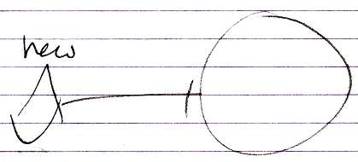

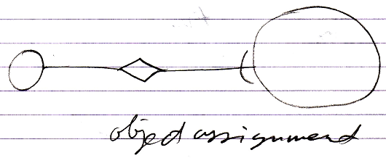

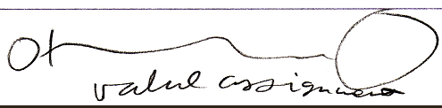

Even though you can also display the system interface and show a call to the command definition:

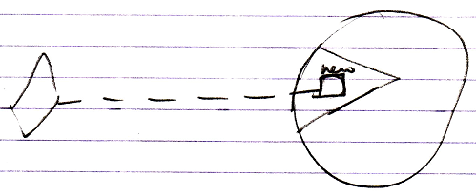

When you very much customize the system interface, you do not always have a standard notation for a consult of the system interface anymore. Giving a related object’s Object Get and Object Set a parameter, you have to display the system interface all the time.

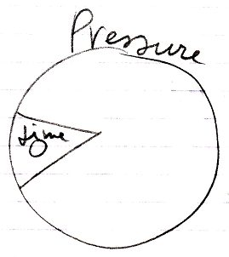

This shows, that the related Pressure object has a Time parameter.

In this case the whole system interface is extended with a parameter, because the Time parameter is not shown in a specific system command or specific system aspect, but shown inside the whole system interface. This means, that with any system command you can supply the Time parameter.

A call to the system command, such as value assignment, will show the Time parameter:

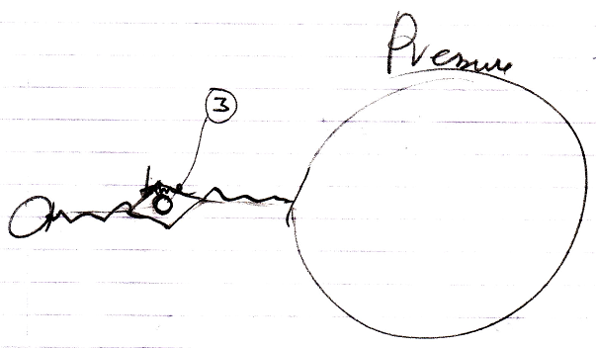

The notation above might not the best one. You may want to show the Time parameter in the related object’s system interface at all times:

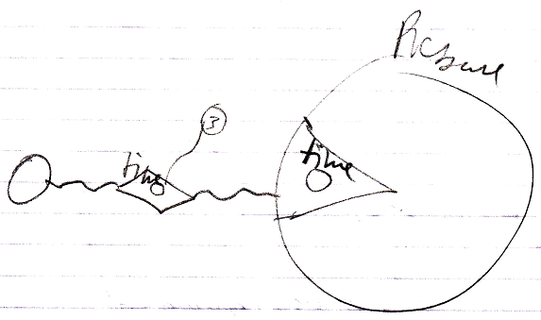

This clearly depicts, that the Pressure related object has a Time parameter. You can not go around this parameter.